A Study of the Existential Value of Media Art: Opening New Possibilities for Existence and Relationship

Haeyoung Youn

Anna Kim's exhibition “Rhapsody 0/1: Digital Depth” utilizes both digital and analog media to address the crisis of natural ecosystems, focusing on environmental pollution (ocean and air pollution), climate change, and Earth's sustainability issues. Kim’s interest in nature deepened through her childhood experiences in the vast wilderness of America and from viewing Earthworks art pieces from the 60s and 70s. In an era of climate crisis, where climate action is being sought at personal, societal, and national levels, Kim's choice to focus on the crisis of natural ecosystems as the theme of her work is closely related to the existential value of art that she has contemplated thus far. In an interview, Kim mentioned her sense of responsibility as a creator and reflected on the existential justification of her work. This exhibition will serve as an opportunity to understand the role and function of Kim’s art, and the use of digital and analog media will be conveyed through experimental and practical methodologies.

The two key elements to understand in this exhibition are fiction and digital media. Kim unfolds the theme of the crisis in natural ecosystems, occurring in reality, set against a backdrop of stories she has created herself. This process involves inserting fiction into reality to create imaginative transformations; and in this context, the participation of viewers interacting with digital technology plays an important role. Upon closer examination, fiction can be seen as an artistic device used by Kim to compose her work, which can be divided into formal and content-related aspects. First, in terms of form, Kim’s works “Water Has Memory,” “El Nino & La Nina Series,” and “Lev-AI-than” combine heterogeneous elements, such as the gods of mythology, the dragon lady from the future that has already arrived, cyborg siblings of El Niño and La Niña, and the iconization of the doughnut economic model, to raise awareness of the environmental, climate, and sustainability crises facing the planet. This involves connecting existing symbols and images into new relationships to convey meaning, an act that Jacques Rancière refers to as the “fiction of the aesthetic regime,” which reconstructs or re-frames reality. the aesthetic regime.”

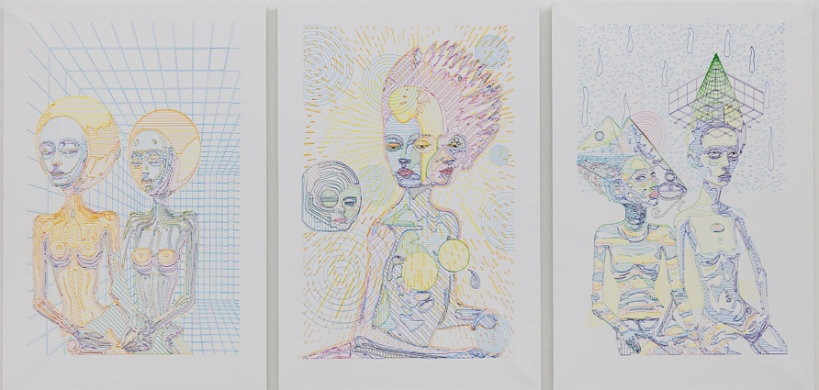

El Nino & La Nina Series
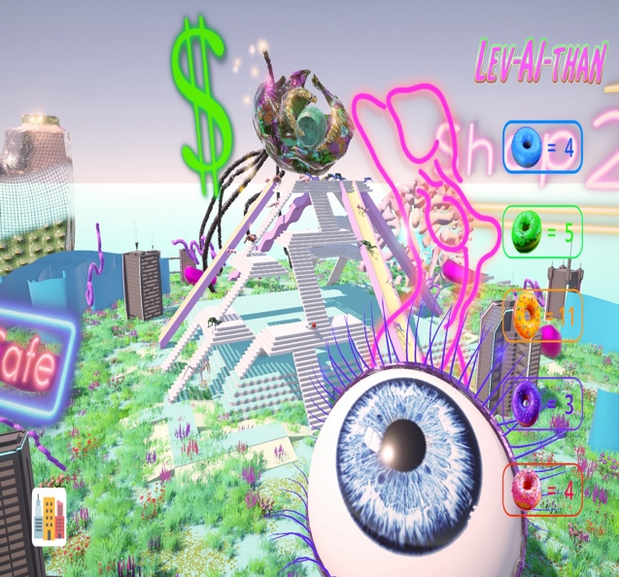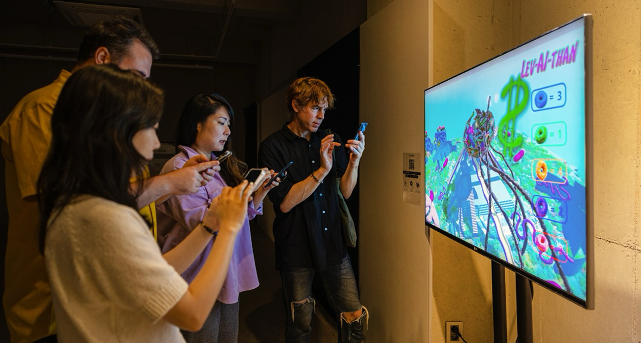

Lev-AI-than

Rancière argues that the Latin origin of the word fiction, fingere, means “to create” rather than “to pretend,” emphasizing the importance of the constructive act that allows us to perceive something as art, independent of its relation to reality. This also involves restructuring our perceptual framework. Kim reinterprets climate and environmental issues through the rearrangement of signs and images, transforming viewers into participants who are conscious of such natural ecosystem crises. In terms of the content of fiction, Kim addresses the crisis of natural ecosystems against the backdrop of stories she has created, and this fictional narrative possesses the “power of the false” as mentioned by Gilles Deleuze. This does not simply emphasize that the artist's story is false; rather, it means that this falsehood has a significant impact on reality, enough to dismantle the very system of judging truth and falsehood. For example, in “Water Has Memory,” visitors take on the role of 'becoming Soohyun,' a character responsible for the fate of the marine environment, through their own physical movements. Such acts empower visitors as agents in creating a better world. Therefore, Kim's works, endowed with the “power of the false,'” may have a paradoxical tone, but ethically, they possess the power to transform or create our subjectivity, opening up new possibilities for life.

Meanwhile, “becoming Soohyun” is a sensory experience formed through the interaction between the viewer, digital media, and AI technology. This experience occurs not at the level of conscious perception, but within the material realm of the body. It relates to the concept of “being-in-the-world” mentioned in phenomenology, where the sensing being experiences itself within and alongside the world. Therefore, through the sensory experience of “becoming Soohyun,” we not only shift the mode of existence from being to becoming, but also establish affective resonances with beings beyond the human. In Kim's media works, it is noteworthy that digital media go beyond the technical aspects of processing, storing, expressing, and transmitting information to create new sensations. As Kim hopes, this can serve as a means to restore our relationship with nature on an aesthetic level. Ultimately, Kim's works possess aesthetic and ethical characteristics in that they produce new subjectivities through sensory experiences. This reflects the value of art as pursued by Kim, signifying that art and life are not separate, and through art, new dimensions and various possibilities are opened up in life.

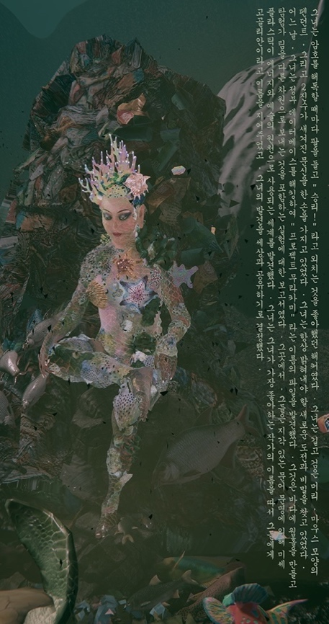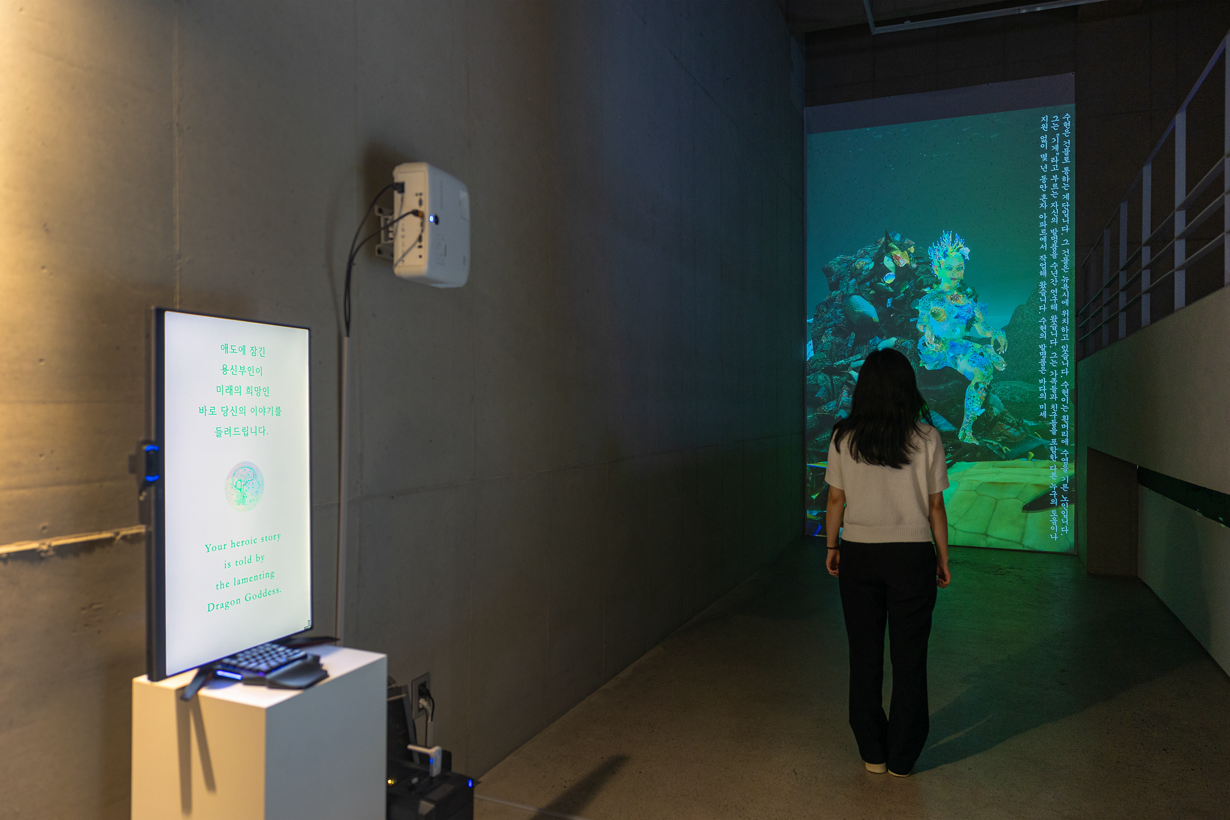

Water Has Memory: Real-time Interaction with AI

