Drawing the Time That Is Perceived

Haeyoung Youn

In the works of Hwang Hae-yeon, glaciers are a significant subject, often referred to as the "Glacial Form Study Series." In these works, glaciers are depicted using various graphic patterns composed of black lines and white surfaces. The simplified geometric patterns of the glaciers can be methodologically linked to Mondrian's cold abstraction. However, the glaciers in her work need to be approached from the figural aspect mentioned by Gilles Deleuze. According to Deleuze, visual images are divided into the figurative and the figural. Figurative images represent the subject in a reproductive, illustrative, and narrative manner, while figural images express the force, sensation, or intensity of the subject.
In the artwork, the depicted glacier shows a body of ice experiencing external forces. The glacier's inner strength, resisting global warming, is represented by a large rhombus composed of long black lines. Meanwhile, the currently melting glacier is portrayed with its middle part crudely hollowed out and twisted. This is expressed by short, thick black lines abruptly invading the white surface, conveying a precarious situation where the middle layer of the glacier struggles to support the whole. Additionally, the glacier, almost completely melted into water, is represented by black curves, while the glacier already melted under the sea level is depicted like a shadow painted with correction fluid, symbolizing discontinuity and disappearance of existence.
The reason for aesthetically approaching the various forms of glaciers is because the forces acting on the glacier's body create conditions for sensory experiences. Phenomenologist Erwin Straus distinguishes between basic differences in perception and sensation, asserting that sensory experiences precede perceptual experiences, which are oriented towards rational structures. Straus defines sensory experience as the experience of 'being-together,' where subject and object both manifest, not as sensations owned by the subject, but rather, the subject discovers themselves within the sensation. This implies that in sensory experiences, the formation of the subject and the emergence of the world occur simultaneously. Deleuze reinterprets these sensory experiences as perception and affect. He defines perception not as human perceptual action, but as 'the inhuman landscape of nature,' and affect not as human emotional action, but as 'the dehumanization of the human.' According to this concept, sensory experience is not about looking at urban or natural landscapes as objects, but entering the landscape, becoming part of it, and merging within it, which is referred to as 'perception.' The ontological changes that occur to me through this communion with the space are called 'affect.'
This conceptual insight is also applied to the depiction of glaciers in artworks, where the glacier is not merely abstractly expressed but sensually embodied. The glacier, shaped by the artist's perception and affective actions, enables the recognition of invisible forces beyond its visible form. This sensory approach is well reflected in the artist's previous exhibition title, "Becoming a Glacier," and is deeply connected to Paul Klee's assertion that the task of painting is not to reproduce the visible but to make visible the invisible.

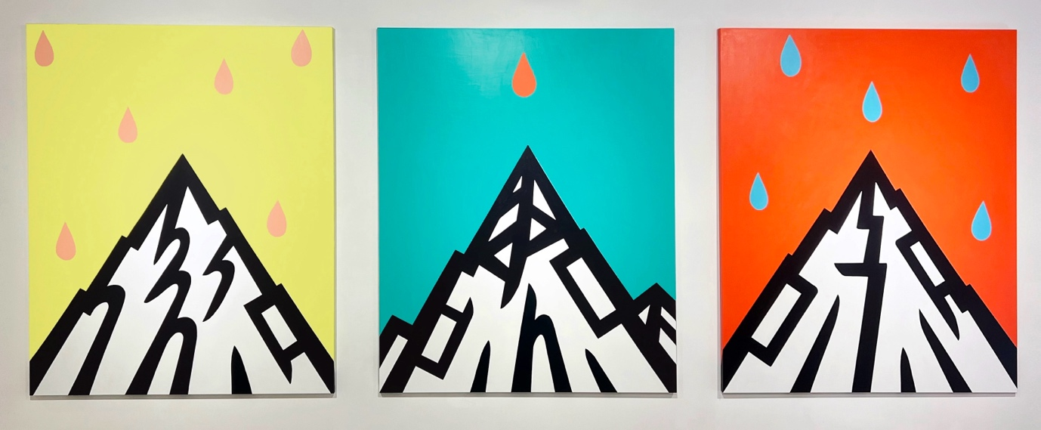
Figure 1: Lemon Yellow Sky, Emerald Green Sky, and Orange Sky. Acrylic on Canvas, 162.2x130(cm), 2023

The Temporal Modulation: The Time of Pure Genesis That Has Already Passed and Is Yet Eternally to Come
The continuous revelation of the glacier's sensual form on the screen originates from its interaction with the background. The screen with the glacier is divided into three parts: the glacier is placed in the foreground, and behind it unfolds a background distinguished by the orange and bright yellow colors combined by the artist (on smaller canvases, the glacier is placed over a background of orange and red colors combined by the artist). In the works "Born as a Glacier, Slept as a Star" and "Moon, Evening Primrose," the orange and bright yellow of the background contain the color energy that forms the space, creating an infinite space where the inside and outside are indistinguishable. In this way, the relationship between the extended space and the glacier is ontologically similar to the folds on a piece of paper. The folds on the paper may seem separate from the paper, but they are actually part of it and cannot be separated. Similarly, despite its various forms, the glacier on the screen is sustained by the energy of the background space.
Furthermore, just as the folds on paper create a sense of three-dimensionality and seem to distinguish themselves from the paper, the glacier also evokes three-dimensionality within its relationship with the background. Orange and bright yellow (or orange and red) are classified as adjacent colors on the Munsell color wheel, emphasizing a smooth transition and flow through subtle differences rather than stark contrasts. The warm hues of the background highlight the glacier's black lines and white surfaces in the foreground, creating an optical illusion that the glacier protrudes from the screen. This sense of three-dimensionality in the glacier is not depicted through perspective space using a vanishing point, but is realized through 'haptic vision' on a monochromatic plane. That is, the length, thickness, and direction of the lines forming the glacier on the plane produce a movement that feels like visually touching it.
Beyond this visual experience, the interaction between the glacier and the background also influences the way we experience time. The sensual form of the glacier positioned at the forefront of the screen represents the state of instantaneous change through the intensity difference between 'less' and 'more.' The moment of change occurring between 'less' and 'more' is difficult to explain using traditional concepts of time. The time we experience in daily life centers around the present, connecting the past and the future, and has a linear and continuous structure of 'past-present-future.' However, if the present is a moment of change, then strictly speaking, the transition from the past to the present and from the present to the future happens simultaneously. Therefore, the present, as a moment of change, encompasses both the past as it passes and the future as it arrives. Deleuze says that in a time where past, present, and future coexist, the present is constantly divided into the past and the future.
The coexistence of past, present, and future understands time not merely as a metric for measuring space and distance, but from the perspectives of change and continuity. In this layered temporal structure, the past does not merely signify events that have passed but becomes a repository accumulating all experiences and ongoing memories. The present, as a moment of change, immediately becomes the past and simultaneously opens up the future. The future exists not as a fixed destination or predetermined outcome but as a dimension of potential possibilities that could materialize. Therefore, the present as a moment encompasses the potential of the future and the possibilities of change. In this simultaneity of time, the past does not follow the present but exists 'together' with it, and the future is not merely ahead of the present but exists 'together' with it as potential. When past, present, and future are interconnected in this way, the linear flow of time offers opportunities for new directions and possibilities beyond anticipated outcomes or choices.
Revisiting the artwork, the glacier and the two divided backgrounds surrounding it can be seen as forming a temporal structure where past, present, and future coexist. The moment the glacier changes from 'less' to 'more' represents the present, the background at the bottom represents the passing past, and the background at the top represents the approaching future. For example, in the work "Born as a Glacier, Slept as a Star," the past coexisting with the present is emphasized. Here, the glacier does not simply disappear as a past event, but continuously persists within the deep memory of the star, embodying its unique identity distinct from other stars. Conversely, in "Moon, Evening Primrose," the realm of potential and possibilities within the future is highlighted. The evening primrose at the top of the screen is drawn only with outlines in Permanent Blue Light, embedded in a bright yellow background, representing not a direct depiction of a real evening primrose, but as a potential existence in a symbiotic relationship with the glacier, reminiscent of a tracing book outlined against the background. As can be seen in these works, the glacier folds and unfolds within time, continuously generating existence. In the past, the glacier folds continuous memories into the folds, and in the future, it unfolds these memories to create novelty. Thus, within the modulation of time, the glacier repeatedly folds and unfolds, creating ontological differences and maintaining its sensual form through this process.

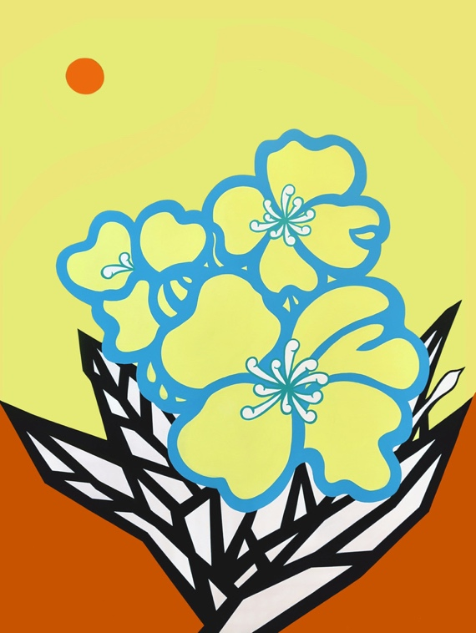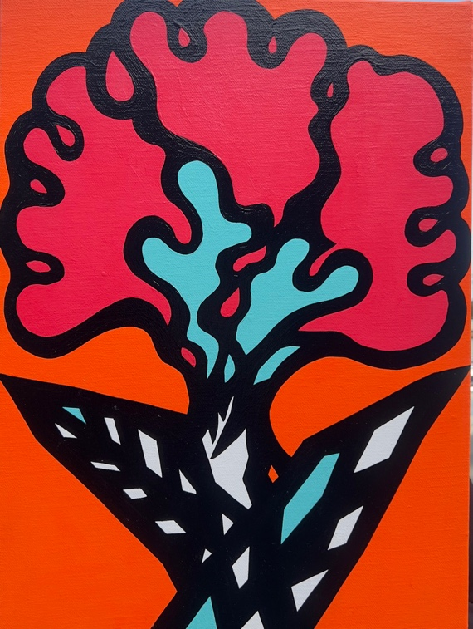
Figure 2: I Pray That This Night Will Never End Figure 3: Like a Fact Cockscom

The Memory of the Future: Creating the Coming Populace
The series of glaciers painted on small canvases (41X32 cm) seem to hold fragments of a future time not yet arrived, like scattered puzzle pieces. The connecting link among these fragments is 'memory.' Generally, memory is associated with past events or experiences, but Friedrich Nietzsche argued from a prehistorical cultural perspective that memory does not merely recall the past but plays a crucial role in constructing the future. The 'Memory of the Future' Nietzsche refers to is not a sentimental memory but one filled with the power of will, remembering declarations and promises beyond mere traces or marks. This means remembering the future itself. 'The Memory of the Future' becomes a key to understanding the artwork "Don't Cry, Don't Melt, You'll Become a Glacier." This piece does not merely express a simple sentiment about glaciers turning into water due to global warming, but embodies a will to revert from water back to glaciers and a resolve to remember these moments in the future. In the same vein, the works "I'll Make Wings and Fly," "Rising without Scattering," and "The Resolution of the Glacier" can be understood.
Nietzsche, in relation to the 'Memory of the Future,' emphasizes that what needs to be remembered is not the consensus or decisions of a specific moment in the past, but rather the point in the future when that promise must be fulfilled. The artist, using glaciers as a major subject, is actively engaged in environmental ecological issues. His video works "Glacier, Ice Rink, Ice Floe Abstract Drawing" and "Memories of You Like Starlight" are collaborations with the Seoul Citizens' Environmental Research Institute, capturing the accelerated melting process of glaciers due to global warming in drawings, treated as if they are documenting a life with a limited time. Additionally, his artistic environmental practice unfolds in the direction of 'creating the coming populace' as mentioned by Deleuze. Here, the 'coming populace' does not refer to a specific existing group but signifies a community with unrealized potential possibilities. Deleuze argues that art creates conditions where a new collective subjectivity can emerge toward the future. From Nietzsche's perspective, this means fulfilling the promised actions at a specific future point and simultaneously forming humans who can actively utilize and create the future. As suggested by the title of this exhibition, "Your First Glacier," the artist hopes this exhibition will act as a catalyst for the audience to develop a 'creative will and action' in response to climate change.

